1) MiKTeX 2.9:

You can download it from

http://www.miktex.org/download

You can choose a portable version in Other downloads (no need to install it), or an installer (then you need to install it)

2) TeXnicCenter 2.02

It is available in appstore (if not found, ask ICT to make it available for you)

When first run, it will ask for the location of the pdf maker (MiKTeX). If you installed it, it should be automatically found. In any case, you can find it manually (either the installed or the portable version).

3) Install Python 2.7 (necessary in next step)

From the appstore or from internet

4) deltares_manual_style

It is the document indicating the style of user manual in Deltares

run the file:

install_latex_templates_python.bat

When you try to build the document for the first time,

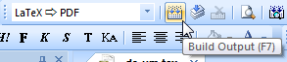

You will be asked to install several packages for different styles, always indicate install

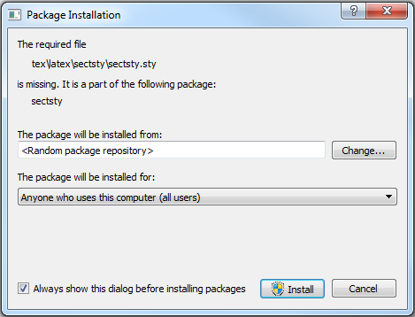

Miktek 2.9 installation on default directory presumed (Windows).

2014-03-03:

Remove first the following existing directories:

c:\Users\<user>.DIRECTORY\AppData\Roaming\MiKTeX\2.9\bibtex\bst\misc

c:\Users\<user>.DIRECTORY\AppData\Roaming\MiKTeX\2.9\templates

c:\Users\<user>.DIRECTORY\AppData\Roaming\MiKTeX\2.9\tex\latex\misc

Copy the directories bibtex, makeindex, deltares_examples and tex to the directory

c:\Users\<user>.DIRECTORY\AppData\Roaming\MiKTeX\2.9\

To assure that the classes can be found by LaTeX

Select from the Start button: MikTeX 2.9 -> Maintenance -> settings -> Press "Refresh FNDB"

Now you are able to make use of the class-files.

end document

5) Open the project file:

ds_um.tcp with TeXnicCenter